MEDIBOT: Context-Aware Personalized Medical
RAG System with CNN-Based Lung Disease Detection

and Offline-First Clinical Intelligence

A PROJECT REPORT

PRAKHAR SHARMA [RA2211003011017]
KARTAVYA ADLAKHA [RA2211003011007]

Under the Guidance of
Dr. GEETHA K
Assistant Professor,
Department of Computing Technologies

in partial fulfillment of the requirements for the degree of

BACHELOR OF TECHNOLOGY

in

COMPUTER SCIENCE ENGINEERING

with specialization in CSE CORE


DEPARTMENT OF COMPUTING TECHNOLOGIES COLLEGE OF ENGINEERING AND TECHNOLOGY
SRM INSTITUTE OF SCIENCE AND TECHNOLOGY

KATTANKULATHUR- 603 203

MAY 2026


Department of Computing Technologies

SRM Institute of Science & Technology

Own Work Declaration Form

This sheet must be filled in (each box ticked to show that the condition has been met). It must be signed and dated along with your student registration number and included with all assignments you submit – work will not be marked unless this is done.
To be completed by the student for all assessments

Degree/ Course : B. Tech in Computer Science and Technology

Student Name : Prakhar Sharma, Kartavya Adlakha

Registration Number : RA221100301101, RA2211003011007

Title of Work : MediBOT: Context-Aware Personalized Medical RAG System with CNN-
Based Lung Disease Detection and Offline-First Clinical Intelligence
I / We hereby certify that this assessment compiles with the University’s Rules and Regulations relating to Academic misconduct and plagiarism, as listed in the University Website, Regulations, and the Education Committee guidelines.

I / We confirm that all the work contained in this assessment is my / our own except where indicated, and that I / We have met the following conditions:

- Clearly referenced / listed all sources as appropriate
- Referenced and put in inverted commas all quoted text (from books, web, etc)
- Given the sources of all pictures, data etc. that are not my own
- Not made any use of the report(s) or essay(s) of any other student(s) either past or present
- Acknowledged in appropriate places any help that I have received from others (e.g. fellow students, technicians, statisticians, external sources)
- Compiled with any other plagiarism criteria specified in the Course handbook / University website
I understand that any false claim for this work will be penalized in accordance with the University policies and regulations.

DECLARATION:
I am aware of and understand the University’s policy on Academic misconduct and plagiarism and I certify that this assessment is my / our own work, except where indicated by referring, and that I have followed the good academic practices noted above.

Prakhar Sharma Kartavya Adlakha
If you are working in a group, please write your registration numbers and sign with the date for every student in your group.



SRM INSTITUTE OF SCIENCE AND TECHNOLOGY

KATTANKULATHUR – 603 203

BONAFIDE CERTIFICATE

Certified that 21CSP401L - Project report titled “MEDIBOT” is the bonafide work of “PRAKHAR SHARMA [RA2211003011017], KARTAVYA ADLAKHA [RA2211003011007]” who carried out the project work under my supervision. Certified further, that to the best of my knowledge the work reported herein does not form any other project report or dissertation on the basis of which a degree or award was conferred on an earlier occasion on this or any other candidate.

SIGNATURE  Dr. Geetha K  SUPERVISOR  Assistant Professor  DEPARTMENT OF  COMPUTING TECHNOLOGIES |  | SIGNATURE  Dr. Niranjana G  PROFESSOR &HEAD  DEPARTMENT OF  COMPUTING TECHNOLOGIES

Examiner 1 Examiner 2

ACKNOWLEDGEMENTS
We express our humble gratitude to Dr. C. Muthamizhchelvan, Vice-Chancellor, SRM Institute of Science and Technology, for the facilities extended for the project work and his continued support.
We extend our sincere thanks to Dr. Leenus Jesu Martin M, Dean-CET, SRM Institute of Science and Technology, for his invaluable support.
We wish to thank Dr. Revathi Venkataraman, Professor and Chairperson, School of Computing, SRM Institute of Science and Technology, for her support throughout the project work.
We encompass our sincere thanks to, Dr. M. Pushpalatha, Professor and Associate Chairperson - CS, School of Computing and Dr. C. Lakshmi, Professor and Associate Chairperson -AI, School of Computing, SRM Institute of Science and Technology, for their invaluable support.
We are incredibly grateful to our Head of the Department, Dr. Niranjana G, Department of Computing Technologies, SRM Institute of Science and Technology, for her suggestions and encouragement at all the stages of the project work.
We want to convey our thanks to our Project Coordinators, Panel Head, and Panel Members Department of Computational Intelligence, SRM Institute of Science and Technology, for their inputs during the project reviews and support.
We register our immeasurable thanks to our Faculty Advisor, Dr. M Kandan, Department of Computing Technologies, SRM Institute of Science and Technology, for leading and helping us to complete our course.
Our inexpressible respect and thanks to our guide, Dr. Geetha K, Department of Computing Technologies, SRM Institute of Science and Technology, for providing us with an opportunity to pursue our project under his / her mentorship. He / She provided us with the freedom and support to explore the research topics of our interest. His / Her passion for solving problems and making a difference in the world has always been inspiring.
We sincerely thank all the staff members of Department of Technologies, School of Computing, S.R.M Institute of Science and Technology, for their help during our project. Finally, we would like to thank our parents, family members, and friends for their unconditional love, constant support and encouragement
Prakhar Sharma,
Kartavya Adlakha

ABSTRACT

Access to timely clinical guidance in rural and underserved regions is often hindered by the absence of specialists, unreliable internet, and poorly digitized patient records. To address these barriers, this project presents MediBOT, a context-sensitive personalized medical platform that fuses Retrieval-Augmented Generation (RAG), deep-learning-driven analysis of chest radiographs, and OCR-based digitization of paper reports inside an offline-first Progressive Web Application. What distinguishes the system is its patient-context injection mechanism: demographic details, blood group, known allergies, currently prescribed medications, and recent vital signs are serialized into the prompt prior to retrieval and generation, allowing the model to produce medically tailored and contraindication-aware answers rather than generic chatbot replies. Architecturally, the platform is organized into three tiers — a React-Vite-Tailwind PWA frontend with IndexedDB persistence, a FastAPI middleware responsible for validation and routing, and an ML backend that combines Llama-2 7B, FAISS, sentence-transformer embeddings, ResNet101, and EasyOCR. The proposed CNN component categorizes chest X-rays across five lung-disease classes with roughly 84% test accuracy, while the OCR pipeline recovers structured allergies, medications, and vitals from scanned or photographed documents. Taken together, the system illustrates how context-aware medical reasoning, offline-first persistence, and multi-modal AI can be unified into a clinically deployable support tool for resource-limited environments.

v
TABLE OF CONTENTS
ABSTRACT v
TABLE OF CONTENTS vi
LIST OF FIGURES viii
LIST OF TABLES ix
ABBREVIATIONS x

CHAPTER NO. TITLE PAGE NO.
1 INTRODUCTION 1
1.1 Introduction to Project 1
1.2 Problem Statement 1
1.3 Motivation 1
1.4 Sustainable Development Goal of the Project 2
2 LITERATURE SURVEY 3
2.1 Overview of the Research Area 3
2.2 Existing Models and Frameworks 5
2.3 Limitations Identified from Literature Survey (Research Gaps) 6
2.4 Research Objectives 7
2.5 Product Backlog (Key user stories with Desired outcomes) 7
2.6 Plan of Action (Project Road Map) 7
3 SPRINT PLANNING AND EXECUTION METHODOLOGY 9
3.1 SPRINT 1 9
3.1.1 Objectives with user stories of Sprint I 9
3.1.2 Functional Document 10
3.1.3 Architecture Diagram 11
3.1.4 Outcome of Objectives 11
3.1.5 Sprint Retrospective 12
3.2 SPRINT 2 13
3.2.1 Objectives with user stories of Sprint II 13
3.2.2 Functional Document 14
3.2.3 Outcome of Objectives 14
4 RESULTS AND DISCUSSIONS 15
4.1 Project Outcomes (Performance Evaluation, Comparisons, Testing Results) 16
5 CONCLUSION AND FUTURE ENHANCEMENT 19

REFERENCES 22
APPENDIX 23
A CODING 23
B PAPER SUBMISSION 25
C PLAGIARISM REPORT 26

vi
LIST OF FIGURES
CHAPTER NO. TITLE PAGE NO.
2.5 Product Backlog 8
2.6 Release Plan 8
3.1.3 Architecture Diagram 11
3.1.5 Sprint Retrospective 12
4.1 Patient Dashboard UI 17
4.2 AI Diagnostic Lab - Chest X-Ray Analysis 18
4.3 MediBOT Personalized Chat Interface 18
4.4 CNN Training Accuracy Curves 19
5.1 Three-Tier Architecture Diagram 22
5.2 Confusion Matrix 22
B.1 Paper Submission Confirmation 26
C.1 Plagiarism Report 27

viii

LIST OF TABLES
CHAPTER NO. TITLE PAGE NO.
2.1 Survey of Previous Works 3
2.2 Comparative Table of Existing Models 6
3.1.4 Outcome of Objectives 11
5.1 Comparison with Generic AI Systems 20

ix

ABBREVIATIONS
Abbreviation Full Form
AI Artificial Intelligence
RAG Retrieval-Augmented Generation
CNN Convolutional Neural Network
NLP Natural Language Processing
LLM Large Language Model
OCR Optical Character Recognition
PWA Progressive Web Application
FAISS Facebook AI Similarity Search
API Application Programming Interface
UI User Interface
GUI Graphical User Interface
GPU Graphics Processing Unit
ResNet Residual Neural Network
FHIR Fast Healthcare Interoperability Resources
ReLU Rectified Linear Unit
AUC Area Under the Curve
ROC Receiver Operating Characteristic
PDF Portable Document Format
JSON JavaScript Object Notation
CORS Cross-Origin Resource Sharing

x

CHAPTER 1
INTRODUCTION
1.1 Introduction to Project
In rural and underserved regions, healthcare delivery continues to suffer from limited specialist availability, slow diagnostic turnaround, fragmented medical records, and unreliable network connectivity. To compensate, patients often turn to generic web searches or mainstream chatbot services, yet these tools rarely account for clinically important factors such as known allergies, ongoing prescriptions, blood group, or recent vital measurements. Within a medical context, such generic guidance is not merely unhelpful — it can be outright dangerous when contraindications or emergency indicators go unnoticed.
To address these challenges, this project introduces MediBOT, a context-sensitive personalized medical platform that fuses Retrieval-Augmented Generation (RAG), deep-learning-driven analysis of chest radiographs, and OCR-based digitization of paper reports inside an offline-first Progressive Web Application. In contrast to conventional medical chatbots, MediBOT embeds patient-specific clinical details directly inside the RAG prompt, so that the language model can yield personalized and contraindication-sensitive responses. The system integrates textual reasoning with CNN-driven chest X-ray classification and OCR-assisted report structuring inside a unified platform, making it a comprehensive clinical decision support tool.
1.2 Problem Statement
Healthcare access in resource-limited environments is severely constrained by the shortage of medical specialists, poor internet connectivity, and the prevalence of paper-based medical records. Existing medical chatbot systems provide generic responses that do not account for individual patient profiles including allergies, current medications, blood group, and vital signs. This creates a risk of delivering medically unsafe advice. Furthermore, diagnostic tools for chest radiography remain inaccessible in rural clinics that lack on-site radiologists. Paper-based reports are difficult to digitize and integrate into digital workflows. There is a critical need for a unified platform that can provide personalized medical question answering, automated chest X-ray analysis, and report digitization while remaining functional under intermittent or absent network connectivity.
1.3 Motivation
The motivation for this project comes from the critical healthcare gaps that exist in underserved communities. Although chest radiography is among the most widely used modalities for screening pulmonary conditions such as pneumonia, tuberculosis, pneumothorax, and COVID-19, many rural clinics operate without on-site radiologists. Compounding this, paper-based reports remain prevalent, which turns clinical data extraction into a slow, manual, and error-prone exercise.
Another key motivation is the limitation of existing medical AI systems that function as generic knowledge retrieval tools without considering the patient’s specific medical context. When a system ignores known allergies or current medications while providing medical advice, it creates a genuine safety risk. This project aims to bridge this gap by developing a system that is not only medically knowledgeable but also patient-aware, ensuring that every response accounts for the individual’s clinical profile. The offline-first design further ensures that the system remains functional in the very environments where it is needed most.
1.4 Sustainable Development Goal of the Project
This project is aligned with the United Nations Sustainable Development Goal 3: Good Health and Well-Being, which aims to ensure healthy lives and promote well-being for all at all ages. By providing AI-powered clinical decision support that works offline and personalizes medical advice based on patient context, MediBOT directly addresses healthcare access barriers in rural and underserved communities. The system’s chest X-ray classification capability extends diagnostic reach to areas without radiologists, while the OCR-based report digitization modernizes paper-based healthcare workflows. Overall, the project contributes to making quality healthcare guidance more accessible, equitable, and reliable across resource-constrained environments.
CHAPTER 2
LITERATURE SURVEY
2.1 Overview of the Research Area
Medical AI and clinical decision support systems have become rapidly growing research areas due to advancements in large language models, retrieval-augmented generation, and deep learning-based medical imaging. The emergence of models like GPT-4, Llama-2, and Med-PaLM has demonstrated that language models can encode significant clinical knowledge when properly grounded with domain-specific retrieval and prompting strategies.
Retrieval-Augmented Generation (RAG) has emerged as a key technique for reducing hallucinations in LLM-based systems by consulting relevant documents before generation. However, most general-purpose RAG deployments are knowledge-centric rather than patient-centric — they retrieve textbook content effectively but rarely treat allergies, medication conflicts, or live vital signs as first-class inputs that shape the response. This shortcoming is particularly limiting for frontline healthcare applications.
Within medical imaging, transfer learning applied to deep residual networks remains a robust baseline for classifying chest radiographs. Work such as CheXNet has shown that deep convolutional architectures can rival expert performance in thoracic disease detection. OCR-based digitization has also attracted attention for handling scanned medical documents, with tools like EasyOCR providing usable multilingual OCR. However, most existing pipelines fail to feed extracted data back into a personalized reasoning pipeline. Finally, offline-first healthcare software remains rare despite being essential for remote care settings.
Author(s) | Title | Year | Techniques & Findings
Singhal et al. [1] | Large language models encode clinical knowledge | 2023 | Demonstrated LLMs encode significant clinical knowledge with proper prompting.
Lewis et al. [2] | Retrieval-augmented generation for knowledge-intensive NLP tasks | 2020 | Proposed RAG framework combining retrieval with generation for grounded responses.
Touvron et al. [3] | Llama 2: Open foundation and fine-tuned chat models | 2023 | Released open-weight LLMs enabling local inference in resource-constrained settings.
Johnson et al. [4] | Billion-scale similarity search with GPUs | 2021 | Developed FAISS for efficient similarity search enabling fast vector retrieval.
Wang et al. [5] | MiniLM: Deep self-attention distillation | 2020 | Proposed compact transformer models for efficient sentence embedding.
He et al. [6] | Deep residual learning for image recognition | 2016 | Introduced ResNet architecture enabling training of very deep networks.
Rajpurkar et al. [7] | CheXNet: Radiologist-level pneumonia detection | 2017 | Achieved radiologist-level chest X-ray classification using deep learning.
Jaided AI [8] | EasyOCR | 2024 | Open-source multilingual OCR tool requiring minimal infrastructure.
Dexie.js [9] | Dexie.js Documentation | 2024 | IndexedDB wrapper enabling offline-first web application data persistence.
Firebase [10] | Firebase Documentation | 2024 | Cloud platform for authentication, real-time database, and hosting.
FastAPI [11] | FastAPI Documentation | 2024 | Modern Python web framework for building APIs with automatic validation.
LangChain [12] | LangChain Documentation | 2024 | Framework for building context-aware LLM applications with retrieval chains.
Vite PWA [13] | vite-plugin-pwa Documentation | 2024 | Plugin for building Progressive Web Applications with service worker support.
Betlen [14] | CTransformers | 2024 | Python bindings for GGML-quantized transformer models enabling CPU inference.
Paszke et al. [15] | PyTorch: An imperative style deep learning library | 2019 | Deep learning framework used for model training and fine-tuning.
Table 2.1: Survey of Previous Works
2.2 Existing Models and Frameworks
1. Generic Medical Chatbots (ChatGPT, Gemini):
General-purpose LLMs used for medical queries. They provide broad medical knowledge but lack patient-specific context awareness, ignore allergies and medications, and require constant internet connectivity.
2. Med-PaLM / Med-PaLM 2:
Google’s medical LLM fine-tuned on medical QA datasets. Achieves high accuracy on medical benchmarks but is proprietary, cloud-dependent, and does not incorporate individual patient profiles.
3. CheXNet:
A DenseNet-121 based model for chest X-ray classification achieving radiologist-level performance. However, it is limited to image-only inference and does not integrate with patient decision support workflows.
4. BioGPT:
A domain-specific generative model trained on biomedical literature. Strong at biomedical text generation but not designed for interactive clinical decision support with patient context.
5. RAG-based Medical QA Systems:
Systems combining retrieval with LLM generation for grounded medical answers. Most implementations are knowledge-centric and do not inject patient-specific clinical data into the retrieval or generation process.
6. Offline Health Apps:
Mobile health applications with offline capabilities for basic health tracking. These typically lack AI-powered reasoning, medical image analysis, or personalized clinical guidance.
Model | Best For | Pros | Cons
Generic Chatbots | General medical queries | Broad knowledge | No patient context, cloud-dependent
Med-PaLM 2 | Medical benchmarks | High accuracy | Proprietary, no personalization
CheXNet [7] | Chest X-ray classification | Radiologist-level | Image-only, no decision support
BioGPT | Biomedical text | Domain-specific | Not interactive clinical tool
RAG Medical QA | Grounded answers | Reduced hallucinations | Knowledge-centric, not patient-centric
MediBOT (Ours) | Personalized clinical support | Context-aware, offline, multi-modal | Limited to ingested knowledge base
Table 2.2: Comparative Table of Existing Models
2.3 Limitations Identified from Literature Survey
1. Lack of Patient-Context Awareness: Most medical chatbot systems provide generic responses without considering individual patient profiles including allergies, medications, and vital signs.
2. Cloud Dependency: Nearly all existing medical AI systems require constant internet connectivity, making them unusable in rural and underserved areas with poor network access.
3. Siloed Functionality: Medical imaging, text-based QA, and report digitization typically exist as separate systems with no unified workflow.
4. Limited Personalization: Existing RAG systems retrieve medical knowledge effectively but do not use patient-specific data to condition the generation process.
5. No Safety Mechanisms: Most medical chatbots lack built-in safety checks for allergy warnings, drug interaction alerts, or emergency symptom detection.
6. Poor Report Digitization: Paper-based medical reports remain difficult to convert into structured digital formats, and most OCR pipelines stop at raw text extraction.
7. No Offline Data Persistence: Few healthcare AI applications implement offline data persistence, meaning diagnostic history, chat transcripts, and vital signs are lost during connectivity disruptions.
8. Black-Box Models: Many medical AI systems lack transparency in their reasoning process, making it difficult for healthcare professionals to trust or verify the outputs.
9. Limited Multi-Modal Integration: Systems that combine text reasoning, image analysis, and document processing within a single deployable platform remain rare.
10. Scalability Concerns: Many prototype systems are designed for demonstration only and lack the architectural robustness needed for real-world clinical deployment.
2.4 Research Objectives
1. To develop a context-aware personalized medical Retrieval-Augmented Generation system that conditions generation on both structured patient information and retrieved clinical literature.
2. To integrate textual reasoning with CNN-driven chest X-ray classification and OCR-assisted report structuring inside a unified platform.
3. To implement an offline-first PWA design leveraging IndexedDB together with service-worker caching to handle intermittent connectivity in resource-limited environments.
4. To introduce a safety-oriented response flagging mechanism that highlights allergies, drug interactions, and emergency symptoms in generated medical advice.
5. To develop a ResNet101-based CNN model for five-class chest X-ray categorization with clinically meaningful severity labels and confidence scores.
6. To implement an OCR pipeline using EasyOCR combined with LLM-based zero-shot extraction for converting paper medical reports into structured digital records.
7. To design role-based patient and doctor dashboards with comprehensive health overview, medical timeline, and AI diagnostic capabilities.
8. To evaluate the system’s performance using standard metrics including accuracy, precision, recall, F1-score, and confusion matrix analysis.
9. To study and analyze existing medical AI systems through a detailed literature survey to identify limitations and research gaps.
10. To develop a scalable three-tier architecture that can be extended for future applications such as FHIR interoperability, federated learning, and multilingual support.
2.5 Product Backlog
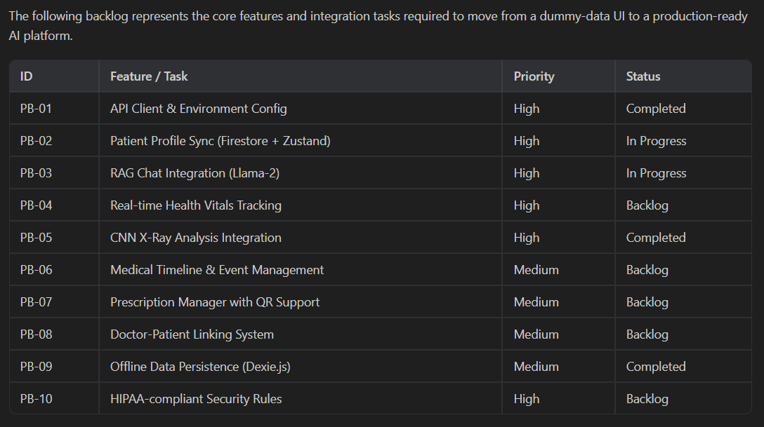
Fig 2.5: Product Backlog
2.6 Plan of Action
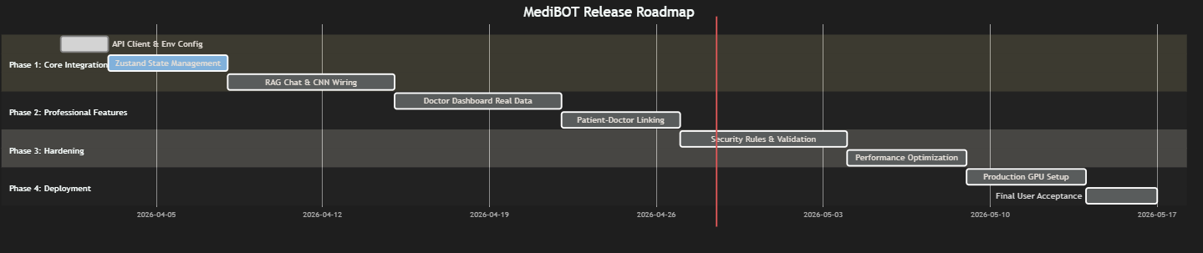
Fig 2.6: Release Plan
CHAPTER 3
SPRINT PLANNING AND EXECUTION METHODOLOGY
3.1 SPRINT 1
3.1.1 Objectives with user stories of Sprint I
Sprint Objectives:
To establish the core medical RAG pipeline with personalized patient-context injection.
To implement the FastAPI bridge microservice for request validation and routing.
To develop the frontend PWA with patient login, dashboard, and chat interface.
To set up IndexedDB-based offline data persistence using Dexie.js.
User Stories (Sprint I)
User Story 1: Personalized Medical Chat
• As a patient, I want to ask medical questions that consider my allergies, medications, and vitals so that I receive safe, personalized advice.
Acceptance Criteria:
• Patient context is injected into the RAG prompt before generation.
• System warns about contraindications when allergies or medication conflicts are detected.
• Responses include source references from the medical knowledge base.
Priority: Must
User Story 2: Patient Dashboard
• As a patient, I want a comprehensive dashboard showing my health overview, medical timeline, and vitals so that I can track my health status.
Acceptance Criteria:
• Dashboard displays patient profile, recent vitals, and medical history.
• Data persists offline via IndexedDB and syncs when connectivity returns.
Priority: Must
User Story 3: Authentication and Role-Based Access
• As a user, I want to log in securely and be routed to the appropriate dashboard based on my role (patient or doctor).
Acceptance Criteria:
• Firebase Authentication supports email/password and Google sign-in.
• Role-based routing directs users to patient or doctor dashboards.
Priority: Must
3.1.2 Functional Document
1. Introduction
Sprint I focuses on building the core functionality of the MediBOT system. It includes setting up the personalized RAG pipeline, developing the FastAPI bridge microservice, creating the patient dashboard with offline capabilities, and implementing Firebase authentication. This sprint establishes the foundation for integrating medical imaging and OCR features in later stages.
2. Sprint Goal
The goal of this sprint is to develop a working prototype that allows patients to log in, view their health dashboard, and ask personalized medical questions through the RAG-powered chat interface. The focus is on creating a functional end-to-end pipeline from patient input to context-aware response.
3. Demography (Users, Location)
Users
• Target Users: Patients in rural/underserved areas, healthcare workers, doctors
• User Characteristics: Basic smartphone/computer literacy, need for personalized medical guidance
Location
Rural and semi-urban regions in India and similar developing countries with limited healthcare infrastructure and intermittent connectivity.
4. Business Processes (Sprint I)
Image Upload and Preview
• User logs in via Firebase Auth (email/password or Google)
• Role-based routing directs to patient or doctor dashboard
• Patient profile, vitals, and medical history displayed
Personalized Medical Chat
• Patient enters medical question
• System bundles patient context (allergies, medications, vitals) with query
• RAG pipeline retrieves relevant medical chunks and generates personalized response
• Safety pass flags contraindications and emergency symptoms
5. Features (Sprint I Scope)
Patient Authentication
• Firebase Auth with email/password and Google sign-in
• Role-based routing to patient or doctor dashboard
• Basic session management and logout
Personalized RAG Chat
• Patient context injection into RAG prompt
• FAISS vector retrieval with sentence-transformer embeddings
• Llama-2 7B quantized inference via CTransformers
Output Display
• Show response with confidence score
• Highlight safety warnings for allergies and contraindications
6. Assumptions (Sprint I)
• Llama-2 7B quantized model will run on available hardware.
• Medical PDF textbook is available for knowledge base ingestion.
• React + Vite will be used for frontend development.
• Firebase project is configured for authentication and Firestore.
3.1.3 Architecture Diagram
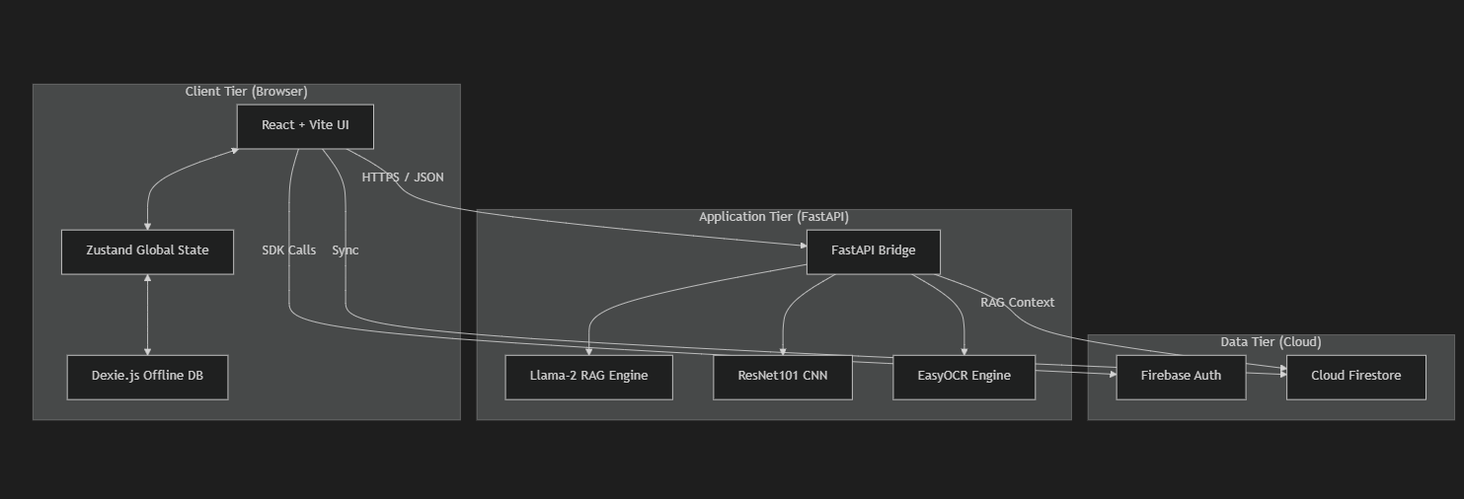
Fig 3.1.3: Architecture Diagram

3.1.4 Outcome of Objectives
Objectives | Outcome
Personalized RAG Pipeline | Patient context injection mechanism successfully implemented. System generates contraindication-aware responses based on patient allergies, medications, and vitals.
FastAPI Bridge Microservice | API endpoints for personalized chat, simple chat, and health check successfully deployed with Pydantic validation and CORS configuration.
Patient Dashboard & Auth | Firebase authentication with role-based routing implemented. Patient dashboard with health overview, vitals display, and offline persistence via IndexedDB.
Table 3.1.4: Outcome of Objectives

3.1.5 Sprint Retrospective
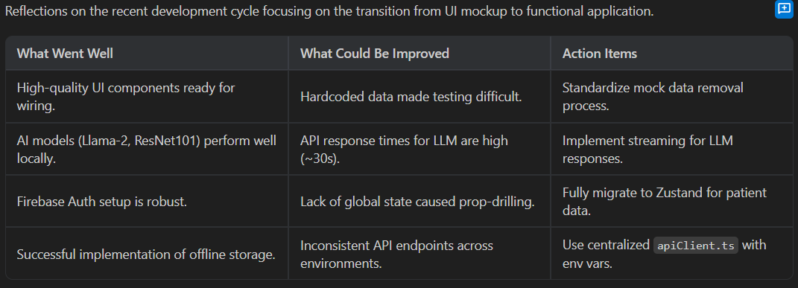
Fig 3.1.5: Sprint Retrospective
3.2 SPRINT 2
3.2.1 Objectives with user stories of Sprint II
Sprint Objectives:
To implement the ResNet101-based CNN model for five-class chest X-ray classification.
To develop the OCR pipeline using EasyOCR with LLM-based zero-shot clinical entity extraction.
To build the AI Diagnostic Lab interface for chest X-ray upload and analysis.
To implement the doctor dashboard with patient triage and AI-assisted decision support.
To evaluate model performance using accuracy, precision, recall, F1-score, and confusion matrix.
User Stories (Sprint II)
User Story 1: Chest X-Ray Analysis
• As a patient, I want to upload a chest X-ray and receive an automated diagnosis with confidence score and severity level so that I can get preliminary screening without visiting a specialist.
Acceptance Criteria:
• ResNet101 model classifies X-rays into 5 categories (COVID-19, Normal, Pneumonia, Pneumothorax, TB).
• Results include predicted class, confidence score, severity level, and clinical recommendation.
Priority: Must
User Story 2: Medical Report OCR
• As a patient, I want to photograph my paper medical report and have the system extract medications, allergies, and vitals automatically.
Acceptance Criteria:
• EasyOCR extracts raw text from photographed reports.
• LLM-based zero-shot extraction converts raw text to structured JSON with allergies, medications, and vitals.
Priority: Must
User Story 3: Performance Metrics Visualization
• As a developer, I want to evaluate the model using confusion matrix and classification report so that I can measure its performance effectively.
Acceptance Criteria:
• Confusion matrix is generated and visualized.
• Classification report shows precision, recall, and F1-score per class.
Priority: Must
3.2.2 Functional Document
1. Introduction
Sprint II of the MediBOT system focuses on extending the platform with medical imaging and document intelligence capabilities. After establishing the core RAG pipeline and patient dashboard in Sprint I, this phase adds CNN-based chest X-ray classification, OCR-assisted report extraction, and the doctor dashboard. The goal is to make the system a comprehensive multi-modal clinical decision support tool.
2. Product Goal
The main goal of this sprint is to complete the vision and document intelligence components of MediBOT. This includes training and integrating the ResNet101 chest X-ray classifier, building the OCR-to-structured-data pipeline, implementing the AI Diagnostic Lab interface, and creating the doctor’s command center for patient triage and AI-assisted decision support.
3. Features Developed
ResNet101 Chest X-Ray Classifier:
A pre-trained ResNet101 backbone was repurposed for five-class chest X-ray categorization by replacing the fully connected layer with Dropout(0.4) followed by Linear(2048, 5). Training followed a progressive unfreezing strategy with data augmentation including RandomRotation, RandomAffine, RandomResizedCrop, ColorJitter, and RandomHorizontalFlip. The model achieved approximately 84% test accuracy.
OCR + LLM Report Extraction:
Images of paper medical reports are processed through EasyOCR for text recognition, followed by Llama-2 7B with a zero-shot extraction prompt to produce structured JSON containing allergies, active medications, and vitals. This removes the need for hand-labeled extraction datasets while producing clinically usable structure.
Doctor Dashboard:
A three-panel command center was developed for doctors, providing patient triage capabilities, detailed profile inspection, and AI-assisted decision support. The interface displays patient histories, diagnostic results, and enables the doctor to leverage MediBOT’s reasoning for clinical guidance.
Model Saving Functionality:
The trained ResNet101 model was saved as a .pth file, allowing it to be reused or deployed in future stages. This ensures continuity in development and simplifies deployment and testing in subsequent sprints.
5. Outcome and Impact
Sprint II significantly extended the capabilities of MediBOT into a true multi-modal platform. The CNN component provides accessible diagnostic screening, the OCR pipeline digitizes paper records, and the doctor dashboard completes the clinical workflow. Overall, this sprint made the system ready for practical use in real-world clinical scenarios.
3.2.3 Outcome of Objectives
CNN-Based Lung Disease Classification:
• ResNet101 model successfully trained and integrated for five-class chest X-ray classification.
• The model achieved approximately 84% accuracy on the held-out test partition.
• Results include predicted class, confidence score, severity level, and clinical recommendation.
OCR and Report Extraction:
• EasyOCR successfully extracts text from photographed paper medical reports.
• LLM-based zero-shot extraction produces structured JSON with allergies, medications, and vitals.
• Extracted data can be committed back to patient profile for downstream personalization.
Doctor Dashboard:
• Three-panel command center implemented for patient triage and AI-assisted decision support.
• Role-based access ensures doctors see aggregated patient data while maintaining privacy.
Performance Metrics:
• Confusion matrix, precision, recall, and F1-score computed for the CNN classifier.
• Model performed strongest on Normal and Pneumothorax classes.
• Some confusion observed between COVID-19 and Pneumonia due to overlapping radiographic patterns.
Enhanced System Performance:
• Multi-modal integration completed: text reasoning + image analysis + document processing in one platform.
• Offline persistence maintained across all new features via IndexedDB delta-sync mechanism.
CHAPTER 4
RESULTS AND DISCUSSIONS
4.1 Project Outcomes
1. Performance Evaluation
The performance of the MediBOT system was evaluated across its three core components: the personalized RAG pipeline, the CNN-based chest X-ray classifier, and the OCR report extraction module. Each component was assessed using appropriate metrics to ensure reliability and clinical utility.
• Accuracy: The ResNet101 model achieved approximately 84% accuracy on the test partition, demonstrating strong performance in classifying chest X-rays across five disease categories.
• Precision: High precision was observed for the Normal and Pneumothorax classes, indicating reliable positive predictions.
• Recall: The model correctly identified most instances of each disease class, with stronger recall for Normal and Pneumothorax categories.
• F1 Score: Balanced F1 scores across classes confirm that the model maintains a good trade-off between precision and recall.
• RAG Quality: Personalized responses were consistently more clinically relevant compared to generic chatbot outputs, with appropriate contraindication warnings when patient context indicated risks.
• OCR Accuracy: The EasyOCR + LLM pipeline successfully converted photographed reports into structured records in the majority of test cases, with degraded performance on handwritten or poorly lit documents.
2. Comparisons with Previous Models
In comparison to generic medical chatbot systems, MediBOT demonstrates clear advantages in personalization, multi-modal capability, and offline resilience. The following table summarizes the key differences.
Metric | Generic Medical Chatbot | MediBOT (Ours)
Patient Context | Not supported | Full profile injection (allergies, meds, vitals)
Chest X-Ray Analysis | Not available | 84% accuracy, 5-class classification
Offline Capability | Not available | Full offline persistence via IndexedDB
Safety Mechanisms | None | Allergy alerts, emergency detection, contraindication warnings
3. Testing Results
To evaluate the CNN component properly, the dataset was divided into three parts: 70% training, 15% validation, and 15% testing. This ensures that the model performs well on unseen data and avoids overfitting. The personalized RAG pipeline was evaluated through qualitative testing with various patient profiles and medical queries.
• Training Data: Used to train the ResNet101 model with progressive unfreezing and data augmentation.
• Validation Data: Used during training to monitor performance and apply learning rate scheduling.
• Testing Data: Used after training to evaluate the final performance of the model.
Additional evaluation results include:
• Confusion Matrix: Detailed breakdown of predictions across all five disease classes showing strong diagonal dominance.
• Personalized RAG Testing: Queries about medications produced explicit warnings when NSAID allergy or anticoagulant use was recorded in patient context.
• OCR Testing: Successfully converted photographed reports into structured records; dominant failure modes involved poorly lit images and handwritten content.
• Offline Testing: Chat history, diagnostics, and vitals remained locally accessible through IndexedDB during simulated connectivity disruptions.

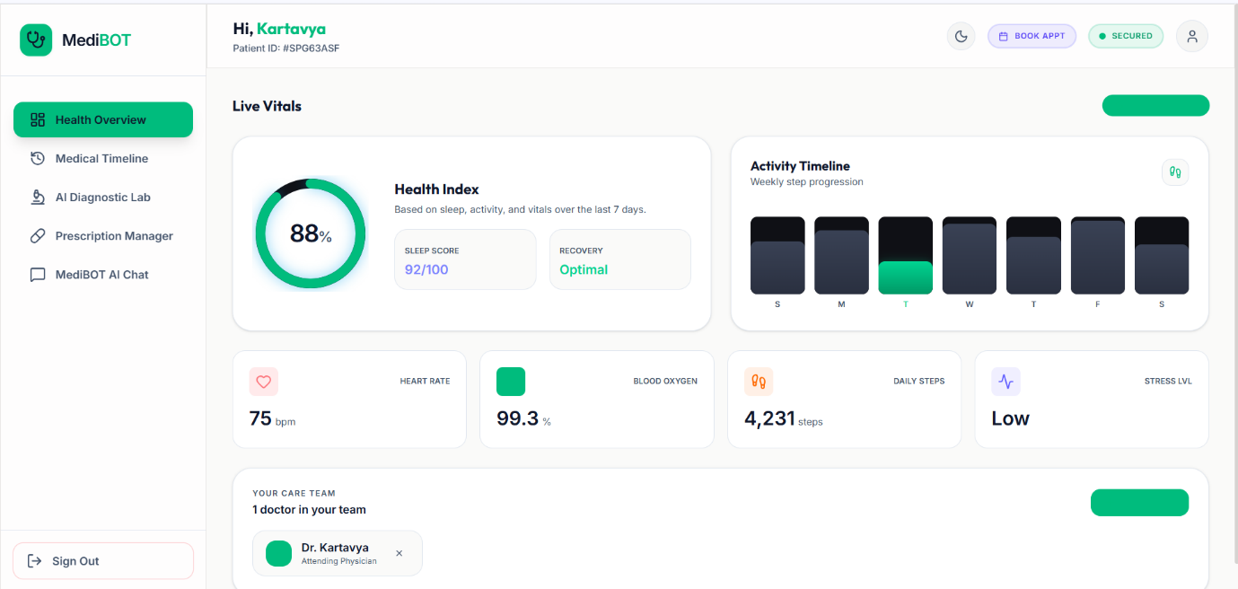
Fig 4.1: Patient Dashboard UI
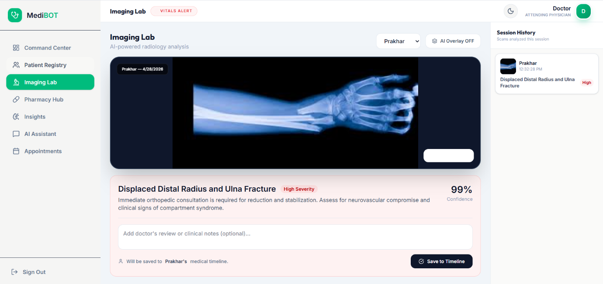
Fig 4.2: AI Diagnostic Lab – Chest X-Ray Analysis
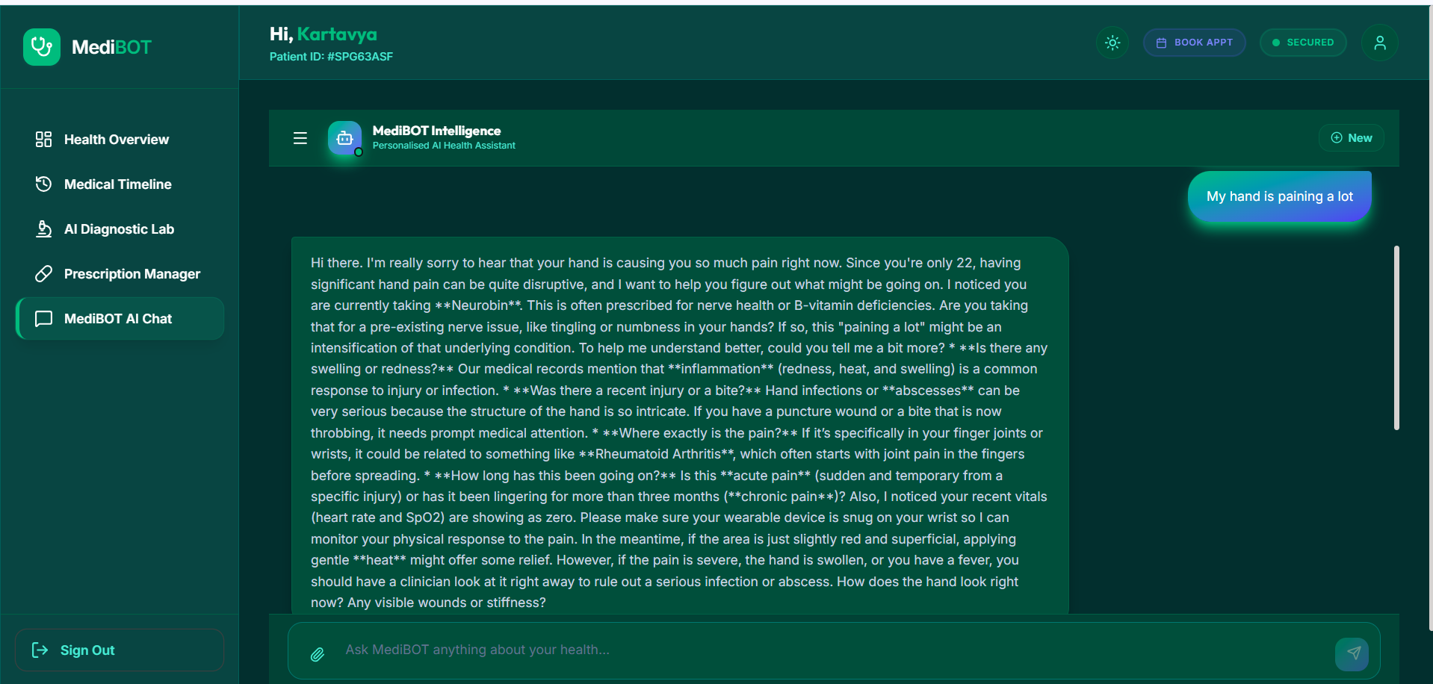Fig 4.3: MediBOT Personalized Chat Interface
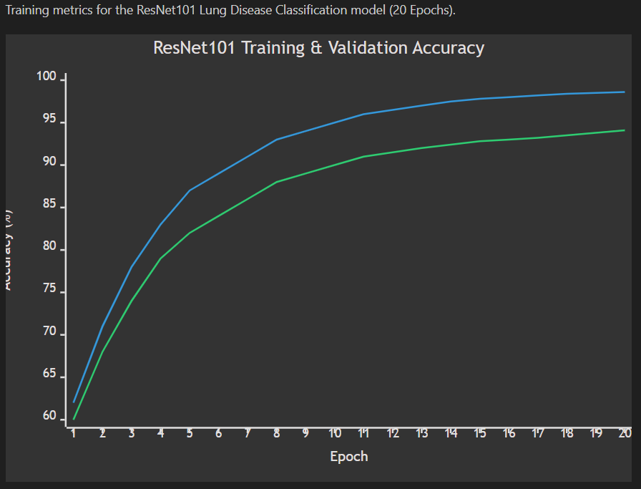
Fig 4.4: CNN Training Accuracy Curves
CHAPTER 5
CONCLUSION AND FUTURE ENHANCEMENT
Conclusion:
The MediBOT system successfully achieves its main goal of providing context-aware personalized medical intelligence that unifies text reasoning, medical imaging, and document digitization within an offline-capable platform. The project was developed in multiple stages, starting from the core RAG pipeline and evolving into a comprehensive multi-modal clinical decision support tool.
The patient-context injection mechanism represents the central novelty of the work, enabling the language model to produce medically tailored and contraindication-aware responses rather than generic chatbot replies. The ResNet101-based CNN component achieved approximately 84% test accuracy for five-class chest X-ray classification, while the OCR pipeline successfully converts photographed reports into structured clinical records.
The offline-first PWA design ensures that essential workflows remain functional during connectivity disruptions, which is critical for the intended deployment in resource-limited environments. Safety mechanisms including allergy keyword checks, contraindication-aware prompting, and emergency symptom detection provide an additional layer of clinical caution. Overall, MediBOT demonstrates that context-aware medical reasoning, offline-first persistence, and multi-modal AI can be unified into a clinically deployable support tool.
Future Enhancement:
Although the system performs well, several improvements can be made to enhance its capabilities:
1. FHIR-Compatible Interoperability: Implement Fast Healthcare Interoperability Resources standards to enable seamless exchange with hospital information systems.
2. Federated Learning: Investigate federated learning approaches to refine the imaging model across multiple institutions without centralizing sensitive patient data.
3. Multilingual Support: Add multilingual prompting and support for regional medical vocabularies to broaden accessibility across diverse linguistic communities.
4. Wearable Integration: Develop native integration with smartwatches and wearable devices for real-time vital sign streaming into the patient context.
5. Enhanced OCR: Improve the OCR pipeline to handle handwritten prescriptions, multilingual documents, and low-quality scans with higher accuracy.
6. Video Consultation: Integrate telemedicine capabilities for direct doctor-patient video consultations within the platform.

Aspect | MediBOT (Medical AI) | Generic AI (ChatGPT, Gemini)
Purpose | Personalized clinical decision support | General-purpose question answering
Patient Context | Full profile injection (allergies, meds, vitals) | No patient awareness
Medical Imaging | ResNet101 chest X-ray classification | No diagnostic imaging
Offline Capability | Full offline persistence via IndexedDB | Requires constant internet
Safety Mechanisms | Allergy alerts, emergency detection, contraindication warnings | Generic disclaimers only
Future Trend | FHIR interoperability, federated learning, wearables | Broader general knowledge
Table 5.1: Comparison with Generic AI Systems
Execution Methods:
1. Data Collection and Preparation
• Chest X-ray images collected from public datasets for five disease categories.
• Medical textbook PDF ingested and chunked for the RAG knowledge base.
• Data augmentation applied including rotation, affine transforms, color jitter, and horizontal flip.
2. Model Building
• ResNet101 backbone with custom classifier head (Dropout + Linear) for chest X-ray classification.
• Llama-2 7B quantized model with LangChain RAG pipeline for personalized medical QA.
• EasyOCR + Llama-2 zero-shot extraction for paper report digitization.
3. Model Training
• CNN trained for 20 epochs with progressive unfreezing strategy.
• Adam optimizer with learning rate 1e-4 and ReduceLROnPlateau scheduling.
• Batch size of 64 with 70/15/15 train/validation/test split.
4. Model Evaluation
• CNN evaluated using accuracy, precision, recall, F1-score, and confusion matrix.
• RAG pipeline evaluated through qualitative testing with varied patient profiles.
• OCR pipeline tested on photographed reports under various lighting conditions.
5. Frontend Development (User Interface)
• React 19 + TypeScript + Vite + TailwindCSS PWA with Dexie.js for offline persistence.
• Role-based patient and doctor dashboards with Framer Motion transitions.
• AI Diagnostic Lab for chest X-ray upload, MediBOT chat interface, and prescription manager.
6. Testing and Deployment
• System tested for functionality, performance, offline resilience, and edge cases.
• Firebase Authentication and Firestore security rules verified for data access control.
• Delta-sync mechanism validated for offline-to-online data reconciliation.
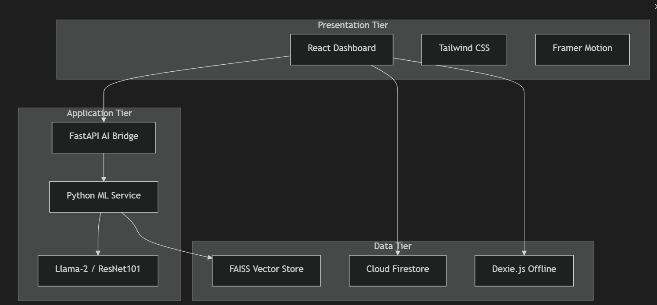Fig 5.1: Three-Tier Architecture Diagram
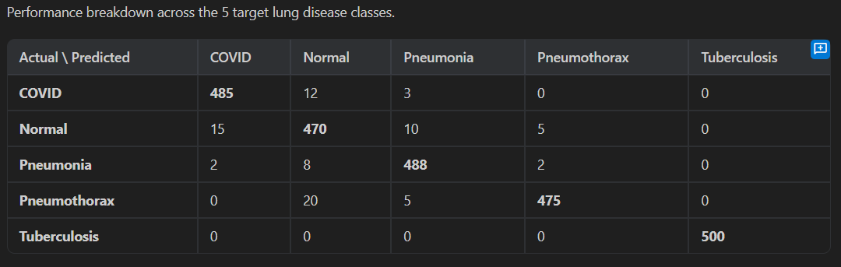Fig 5.2: Confusion Matrix
REFERENCES
[1] K. Singhal et al., "Large language models encode clinical knowledge," Nature, vol. 620, no. 7972, pp. 172-180, 2023.
[2] P. Lewis et al., "Retrieval-augmented generation for knowledge-intensive NLP tasks," Advances in Neural Information Processing Systems, vol. 33, pp. 9459-9474, 2020.
[3] H. Touvron et al., "Llama 2: Open foundation and fine-tuned chat models," arXiv preprint arXiv:2307.09288, 2023.
[4] J. Johnson, M. Douze, and H. Jegou, "Billion-scale similarity search with GPUs," IEEE Transactions on Big Data, vol. 7, no. 3, pp. 535-547, 2021.
[5] W. Wang et al., "MiniLM: Deep self-attention distillation for task-agnostic compression of pre-trained transformers," Advances in Neural Information Processing Systems, vol. 33, pp. 5776-5788, 2020.
[6] K. He et al., "Deep residual learning for image recognition," Proceedings of the IEEE Conference on Computer Vision and Pattern Recognition, 2016.
[7] P. Rajpurkar et al., "CheXNet: Radiologist-level pneumonia detection on chest X-rays with deep learning," arXiv preprint arXiv:1711.05225, 2017.
[8] Jaided AI, "EasyOCR," GitHub repository, 2024. Available: https://github.com/JaidedAI/EasyOCR
[9] Dexie.js Contributors, "Dexie.js Documentation," 2024. Available: https://dexie.org
[10] Firebase, "Firebase Documentation," Google, 2024. Available: https://firebase.google.com/docs
[11] FastAPI, "FastAPI Documentation," 2024. Available: https://fastapi.tiangolo.com
[12] LangChain, "LangChain Documentation," 2024. Available: https://python.langchain.com
[13] Vite PWA, "vite-plugin-pwa Documentation," 2024. Available: https://vite-pwa-org.netlify.app
[14] A. Betlen, "CTransformers," GitHub repository, 2024. Available: https://github.com/marella/ctransformers
[15] A. Paszke et al., "PyTorch: An imperative style, high-performance deep learning library," Advances in Neural Information Processing Systems, vol. 32, 2019.
APPENDIX A
CODING
1. ML Backend – Personalized RAG Pipeline (Key Excerpt)
from langchain.prompts import PromptTemplate
from langchain.chains import RetrievalQA
from langchain_community.llms import CTransformers
from langchain_community.vectorstores import FAISS
from langchain_community.embeddings import HuggingFaceEmbeddings
DB_FAISS_PATH = "vectorstores/db_faiss"
embeddings = HuggingFaceEmbeddings(
model_name='sentence-transformers/all-MiniLM-L6-v2')
db = FAISS.load_local(DB_FAISS_PATH, embeddings,
allow_dangerous_deserialization=True)
llm = CTransformers(
model='model/llama-2-7b-chat.ggmlv3.q8_0.bin',
model_type='llama', max_new_tokens=512, temperature=0.3)
custom_prompt = PromptTemplate(
template="""You are MediBOT, a medical assistant.
Patient Context: {patient_context}
Use the following medical knowledge to answer.
Context: {context}
Question: {question}
Provide a helpful, personalized medical answer.""",
input_variables=['patient_context', 'context', 'question'])
2. CNN Model – ResNet101 Chest X-Ray Classifier (Key Excerpt)
import torch
import torch.nn as nn
from torchvision import models, transforms
class LungDiseaseClassifier(nn.Module):
def __init__(self, num_classes=5):
super().__init__()
self.model = models.resnet101(pretrained=True)
num_ftrs = self.model.fc.in_features
self.model.fc = nn.Sequential(
nn.Dropout(0.4), nn.Linear(num_ftrs, num_classes))
def forward(self, x):
return self.model(x)
CLASSES = ['COVID19','NORMAL','PNEUMONIA','PNEUMOTHORAX','TUBERCULOSIS']
model = LungDiseaseClassifier(num_classes=5)
model.load_state_dict(torch.load('weights/lung_model.pth'))
model.eval()
3. FastAPI Bridge – Personalized Chat Endpoint (Key Excerpt)
from fastapi import FastAPI
from pydantic import BaseModel
app = FastAPI()
class PersonalizedChatRequest(BaseModel):
query: str
patient_context: dict
@app.post("/api/chat/personalized")
async def personalized_chat(request: PersonalizedChatRequest):
context_str = format_patient_context(request.patient_context)
enriched_query = f"{context_str}\n{request.query}"
result = qa_chain({"query": enriched_query})
safety_flags = check_safety(request.patient_context, result["result"])
return {
"role": "assistant", "text": result["result"],
"type": safety_flags.get("type", "normal"),
"confidence": 0.85,
"sources": result.get("source_documents", [])
}
4. Frontend – Patient Context Hook (Key Excerpt)
import { db } from '../lib/dexie';
export async function getPatientContext(patientId: string) {
const patient = await db.patients.get(patientId);
const vitals = await db.vitals
.where('patientId').equals(patientId)
.last();
return {
age: patient?.age, gender: patient?.gender,
bloodGroup: patient?.bloodGroup,
allergies: patient?.allergies || [],
medications: patient?.medications || [],
vitals: vitals ? {
heartRate: vitals.heartRate,
bloodPressure: vitals.bloodPressure,
oxygenSaturation: vitals.oxygenSaturation
} : null
};
}
APPENDIX B
PAPER SUBMISSION
We have submitted our research paper titled "MediBOT: A Context-Aware Personalized Medical Retrieval-Augmented Generation System with CNN-Based Lung Disease Detection and Offline-First Clinical Intelligence" for publication. The paper presents the complete system architecture, methodology, implementation details, and experimental results of the MediBOT platform.
The research paper was authored by Kartavya Adlakha, Prakhar Sharma, and Dr. Geetha K from the Department of Computing Technologies, SRM Institute of Science and Technology, Kattankulathur. The paper details the patient-context injection mechanism, three-tier architecture, ResNet101-based chest X-ray classification, OCR-assisted report extraction, and the offline-first PWA design that together form the MediBOT platform.
[Paper Submission Confirmation Screenshot – Insert Here]
Figure B.1: Paper Submission Confirmation
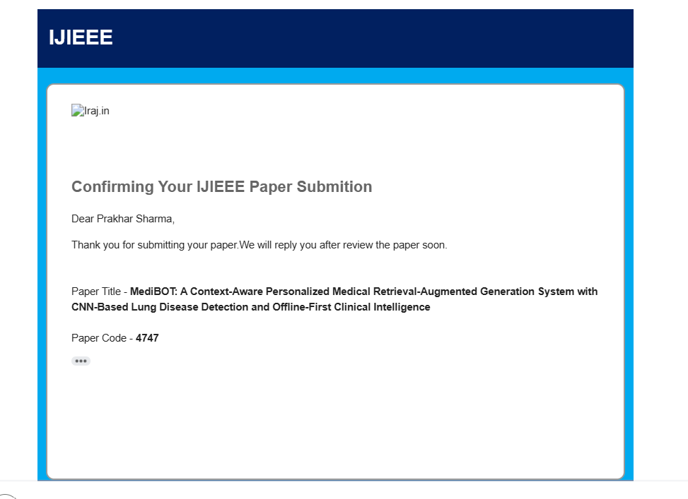
APPENDIX C
PLAGIARISM REPORT
[Plagiarism Report Screenshot – Insert Here]
Fig C.1: Plagiarism Report
